

High Level Scope Document – Closed Loop Digital Wallet

|  |  |
| --- | --- |
| **Client Name** | Al Ansari |
| **Project Name** | Closed Loop Digital Wallet |
| **Request ID** | NIPMO-51834 |
| **Issue date** | 12-Jan-2024 |
| **Version** | 1.3 |
| **Solution Design Manager** | Amit Gaud |
| **Relationship Manager** | Sami Hassan |

**DOCUMENT APPROVAL**

**Version History**

|  |  |  |  |
| --- | --- | --- | --- |
| **Version #** | **Dated** | **Updated by** | **Change** |
| 1.1 | 25-Jan-2024 | Amit Gaud | Draft Proposal document |
| 1.2 | 1-Feb-2024 | Amit Gaud | Details added for merchant application, portal and revised onboarding flow. |
| 1.3 | 1-Feb-2025 | Amit Gaud | Response from AAE |
|  |  |  |  |

**NI Representative**

|  |  |  |
| --- | --- | --- |
| **Name** | **Position / Title** | **Signoff Requirement** |
|  |  | Review |
|  |  | Review |
|  |  | Review |

**Al Ansari Representatives**

|  |  |  |
| --- | --- | --- |
| **Name** | **Position / Title** | **Signoff** |
|  |  |  |
|  |  |  |
|  |  |  |

Table of Contents

1 Requirement 5

2 Glossary of Terms 5

3 High level Scope 5

4 Solution Overview 6

4.1 **Architecture** 6

4.2 **Product hierarchy**  6

4.2.1 **Financial Institution** 7

4.2.2 **Product Definition** 7

4.2.3 **Client /Customer** 7

4.2.4 **Account Contract** 8

4.2.5 **Card Contract** 8

4.3 **Customer Application** 8

4.4 **Customer Registration and Onboarding** 8

4.4.1 **Registration via Mobile application** 9

4.5 **Wallet Activation**  16

4.6 **Customer Classification** 16

4.7 **Acquirer Portal** 16

4.8 **Merchant Wallet Application** 17

4.9 **Merchant Portal** 17

4.10 **Merchant Terminal Application** 17

4.11 **UX and UI For Customer and Merchant Application** 18

4.12 **Customer, acquirermerchant portals** 18

4.13 **Citrix Web Access** 18

4.14 **File/Reports interfaces** 18

4.14.1 **Incoming offline Interface** 18

4.14.2 **Outgoing offline Interface from NI to Al Ansari** 18

4.14.3 **Outgoing offline reports from NI** 19

4.15 **APIs in scope** 19

4.16 **Infra set up** 20

5 Key Assumptions/Solution Considerations 20

6 Out of Scope 20

7 Queries/Outstanding points 21

8 Appendix 21

# Requirement

Al Ansari intends to introduce a closed loop wallet processing for their customers.

# Glossary of Terms

|  |  |  |
| --- | --- | --- |
| **Term** | **Acronym** | **Definition** |
| Network International | NI | Third Party service provider for Issuing |
| Al Ansari | Al Ansari | Wallet Provider |
| Card Management System | CMS | Way4 CMS |
| Transaction Switch | Switch | Base24 Switch |
| FOO | FOO | Digital Channel Provider |

# High level Scope

* Financial Institution (FI) set up for Al Ansari in NI UAE platform.
* One product with closed loop processing.
* Customer mobile application development for wallet management
* Balance hosting in NI CMS
* Base24 switch interface
* Authorization and Transaction processing
* Merchant application for payment acceptance
* NI middleware integration via NI API gateway (JSON via REST APIs)
* Way4 web Portal view access to CMS screens
* Operations service –
  + Settlement
* Key management
* User management
* Standard batch interfaces and reports exchange via SFTP
* Infrastructure set up

# Solution Overview

## **Architecture**

* Below is the architecture design for the Al Ansari Digital Pay -

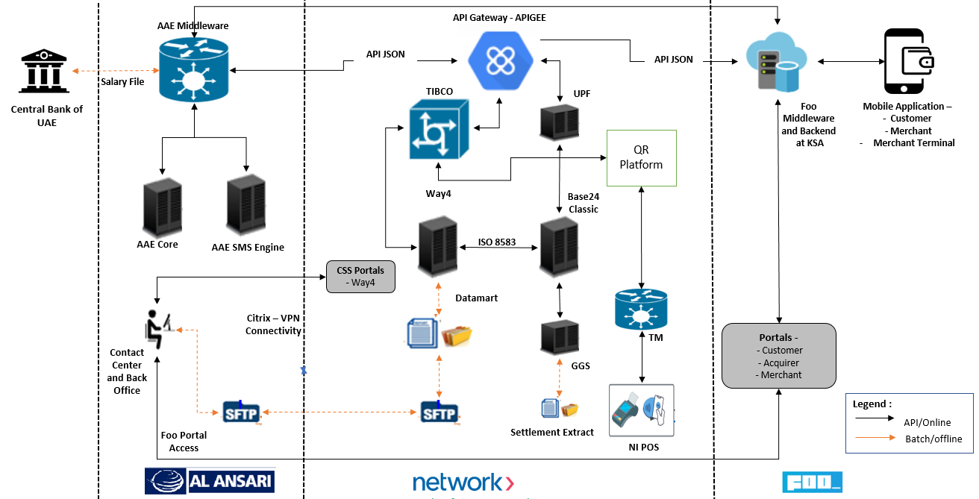

## **Product hierarchy**

* Following depicts the proposed hierarchy for Al Ansari FI/Product set up in NI CMS system.
* 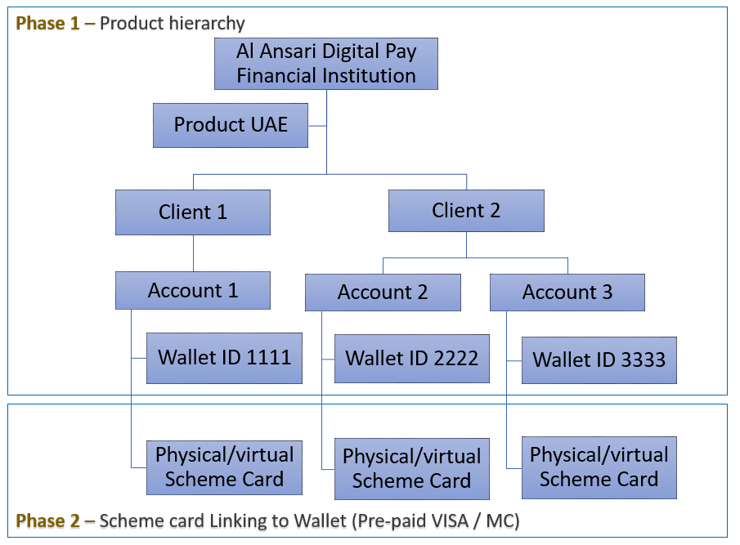

Below are the detailed explanation for each hierarchy explained in above product hierarchy -

### **Financial Institution**

* Setting up a product in CMS starts by defining the Financial Institution (FI). FI is at the top of product hierarchy. The CMS platform is capable of multi-institution setup, which allows to operate each FI as separate business and have its own set of reports/interfaces, access controls, feature controls.
* The following table describes an example of FI level parameters to configure Al Ansari on the CMS platform. These parameters are also called global parameters, which affect the behavior of all the accounts or products setup under its hierarchy.

**FI Level Parameters:**

|  |  |
| --- | --- |
| Parameter | Value |
| Financial Institution Name | Al Ansari |
| Financial Institution Code | 324 |
| Country | UAE |
| FI Currency Code | AED |
| VAT on life cycle fees | TBC |
| Falcon Enabled | No |
| Card Control Enabled | No |

### **Product Definition**

* The standard product setup provides a set of basic product templates ready to use. Products can be setup with standard parameters that are already available in the preconfigured product templates.

|  |  |
| --- | --- |
| Product type | Prepaid |
| Product schemes | Not Applicable |
| Card Type | Virtual Card |
| Cardholder billing currency | AED |
| Settlement currency | AED |
| Product BIN (8-digit BIN) | Not Applicable |
| Product name | Closed Loop Digital Wallet |

### **Client /Customer**

* Client level is used to store customer’s name, and other demographic details.
* Client number (CIF) will be generated by Al Ansari for each cardholder. This will be provided by Al Ansari during customer onboarding process.
* API for Client Create -<https://developer.network.ae/docs/read/card_services/version_2/Client_Create>
* Al Ansari will provide the CIF number which is 16 bytes numeric.

### **Account Contract**

* This level holds the financials, open to buy limit which is used for authorization.
* Account Contract number will be generated by NI as per the NI standard naming convention. Format as follows "000" + <3-digit FI code> + <111> + <10 digits sequentially incremented> (total 19 digits).
* API for Account Create - <https://developer.network.ae/docs/read/card_services/version_2/Account_Create>

### **Card/Wallet ID**

* The 19 byte Wallet ID contract will be treated as wallet ID for Al Ansari. The card will not be issued for the Wallet.
* The Wallet ID will be generated by NI CMS system with the unique Wallet ID generated for each customer under an account.
* As part of onboarding the wallet will be shared with Al Ansari for any of the financial posting in further process flow.
* The Wallet ID will be generated with a predefined number generation logic.
* Once the wallet is created in NI system, it will be in in-active status. The Wallet needs to be activated to use other services.
* API for Wallet Create - <https://developer.network.ae/docs/read/card_services/version_2/Card_Create>

## **Customer Application**

* New wallet management and customer registration mobile application will be designed for Al Ansari. The application will be white labeled application with Al Ansari branding.
* The application will be hosted in IOS and Android Store for customer to download and use the application for wallet management.
* Wallet to be available for download in UAT store (apple/google). To be confirmed.
* Wallet will be designed to support below languages –
  + Arabic
  + English
  + Other language support to be part of Phase 2 / 3
* Application primarily supports below functions for customer usage -
  + Customer Registration
  + Customer Profile Management
  + Login Support
  + Wallet management
  + Payment options
    - * Wallet to Wallet Transfer
      * Payment to Merchant
      * International Remittance
      * Bill Payment
      * Request to Pay (To be part of phase 2 /3 )
* Application will support Biometric and PIN function as an authentication for customer login.

## **Customer Registration and Onboarding**

* Customer onboarding will be supported only via customer mobile application. Customer will download the application from the IOS or Android store for initiating and completing the onboarding process.
* The mobile number provided by customer will be used to authenticate customer as part of verification during onboarding and all further SMS notifications.
* The application will be integrated with SDK provided by Al Ansari to perform eKYC process for customer. The SDK will accept Emirates ID to capture EID details and subsequently APi’s will be integrated to perform eKYC process.
* Al Ansari will screen the customer type and decision whether the eKYC request to be initiated with EFR –
  + New customer will be required to go through complete eKYC process via EFR.
  + Existing customers the data form will be pre-filled as per details received from AAE.
* New wallet created in NI CMS will be in in-active state i.e. after wallet creation the wallet status will be in-active. When wallet is in-active customer will not be able to use below services -
  + - * Wallet to Wallet Transfer
      * Payment to Merchant
      * Remittance
      * Bill Payment
* NI CMS will include the status in the Base24 Host to restrict Wallet usage during stand-in process till the wallet is activated.
* The Wallet status field will be provided to Foo based on which the Wallet options can be enabled or disabled.

### **Registration via Mobile application**

The onboarding journey is divided into two main phases. The first phase is accomplished on the consumer wallet application and consists of 3 main parts. Each part represents a checkpoint for the user performing the onboarding. The second phase is handled on Al Ansari system, representing the process of either accepting or rejecting the consumer self-registration.

The below describes the onboarding journey on the consumer wallet application.

Part 1: Credentials Setup

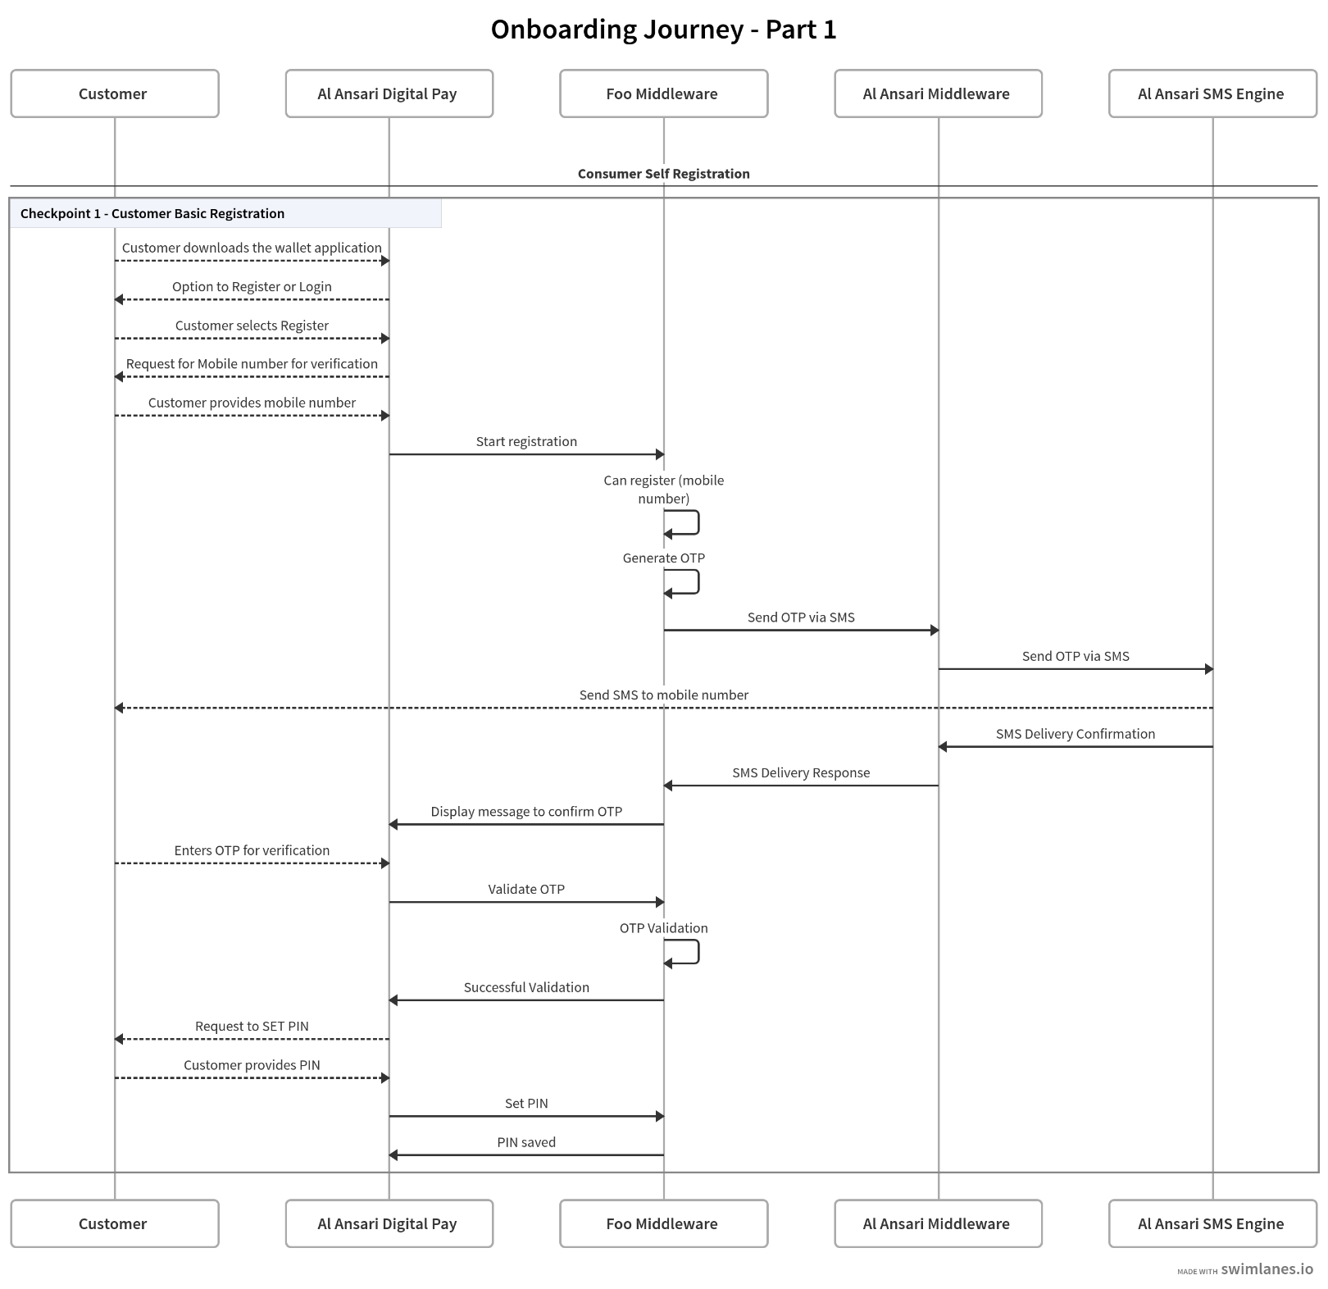

**Step 1:** Customer downloads and installs AlAnsari digital Wallet application.

**Step 2**: Customer opts for registration.

**Step 3**: Customer inputs a UAE mobile number and an email address.

**Step 4**: FOO backend system checks that the provided mobile number is currently linked to another wallet.

**Step 5**: As part of the mobile verification process, FOO backend system generates and sends an OTP to the customer via Al Ansari Middleware / SMS Engine.

**Step 6**: Customer inputs the received OTP which is eventually validated by the FOO backend system and the user is flagged as the rightful owner of the mobile number.

**Step 7**: Customer sets a PIN for the wallet , which is securely stored within FOO backend system.

* + Part 2: EID and Face scanning.

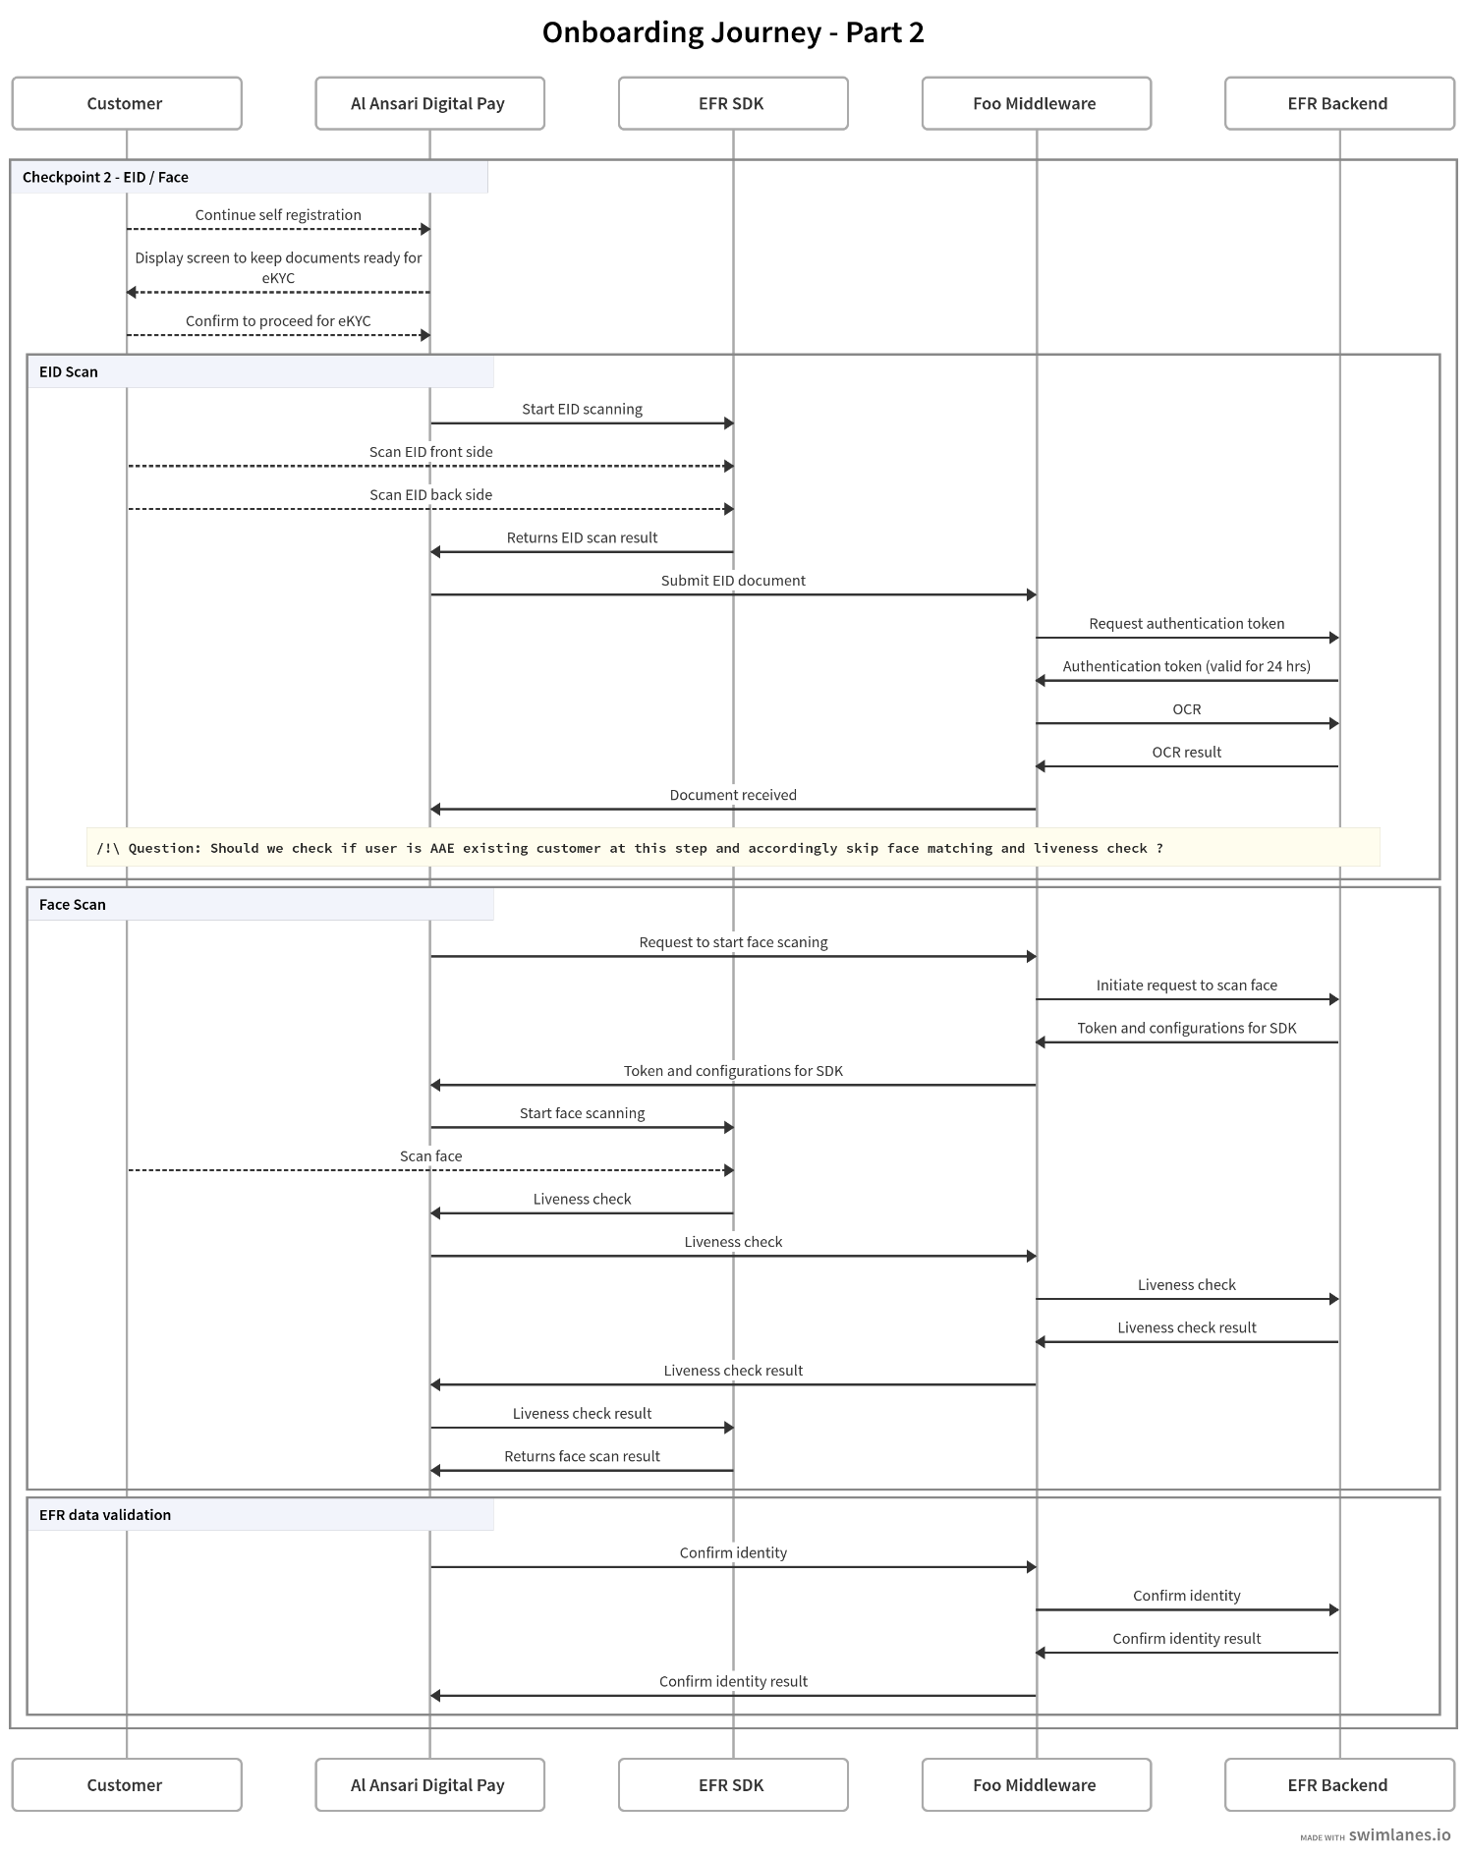

**Step 1**: The application informs the user about the next step, to prepare the identity document.

**Step 2**: The application starts the EID EFR SDK which will allow the customer to capture the EID front and back sides.

**Step 3**: The application captures the documents from the SDK and submits them to the FOO backend system.

**Step 4**: FOO backend system requests an authentication token from EFR backend system, which provides a token that is valid for 24 hours, used for all backend to backend communication with EFR system.

**Step 5**: FOO backend system submits the EID document to EFR backend for OCR analysis, which will result in capturing the EID details.

**Step 6**: The results are shared back with the application, which will continue with the next step.

**Step 7**: FOO backend system requests the needed data to start the Face EFR SDK, from the EFR backend, and provides them to the application.

**Step 8**: The application starts the Face EFR SDK which will allow the customer to capture an image of the face for liveness check.

**Step 9**: The application submits the captured document to the FOO backend system.

**Step 10**: FOO backend system submits the face document to EFR backend for liveness check.

**Step 11:** The results are shared back with the application, which will continue with the next step.

**Step 12:** FOO backend system submits both documents retrieved from both SDKs to EFR backend to confirm that the user captured during the liveness check is the rightful owner of the presented EID.

**Step 13**: The results are shared back with the application, which will continue with the next step.

* + Part 3: EID and Face scanning.

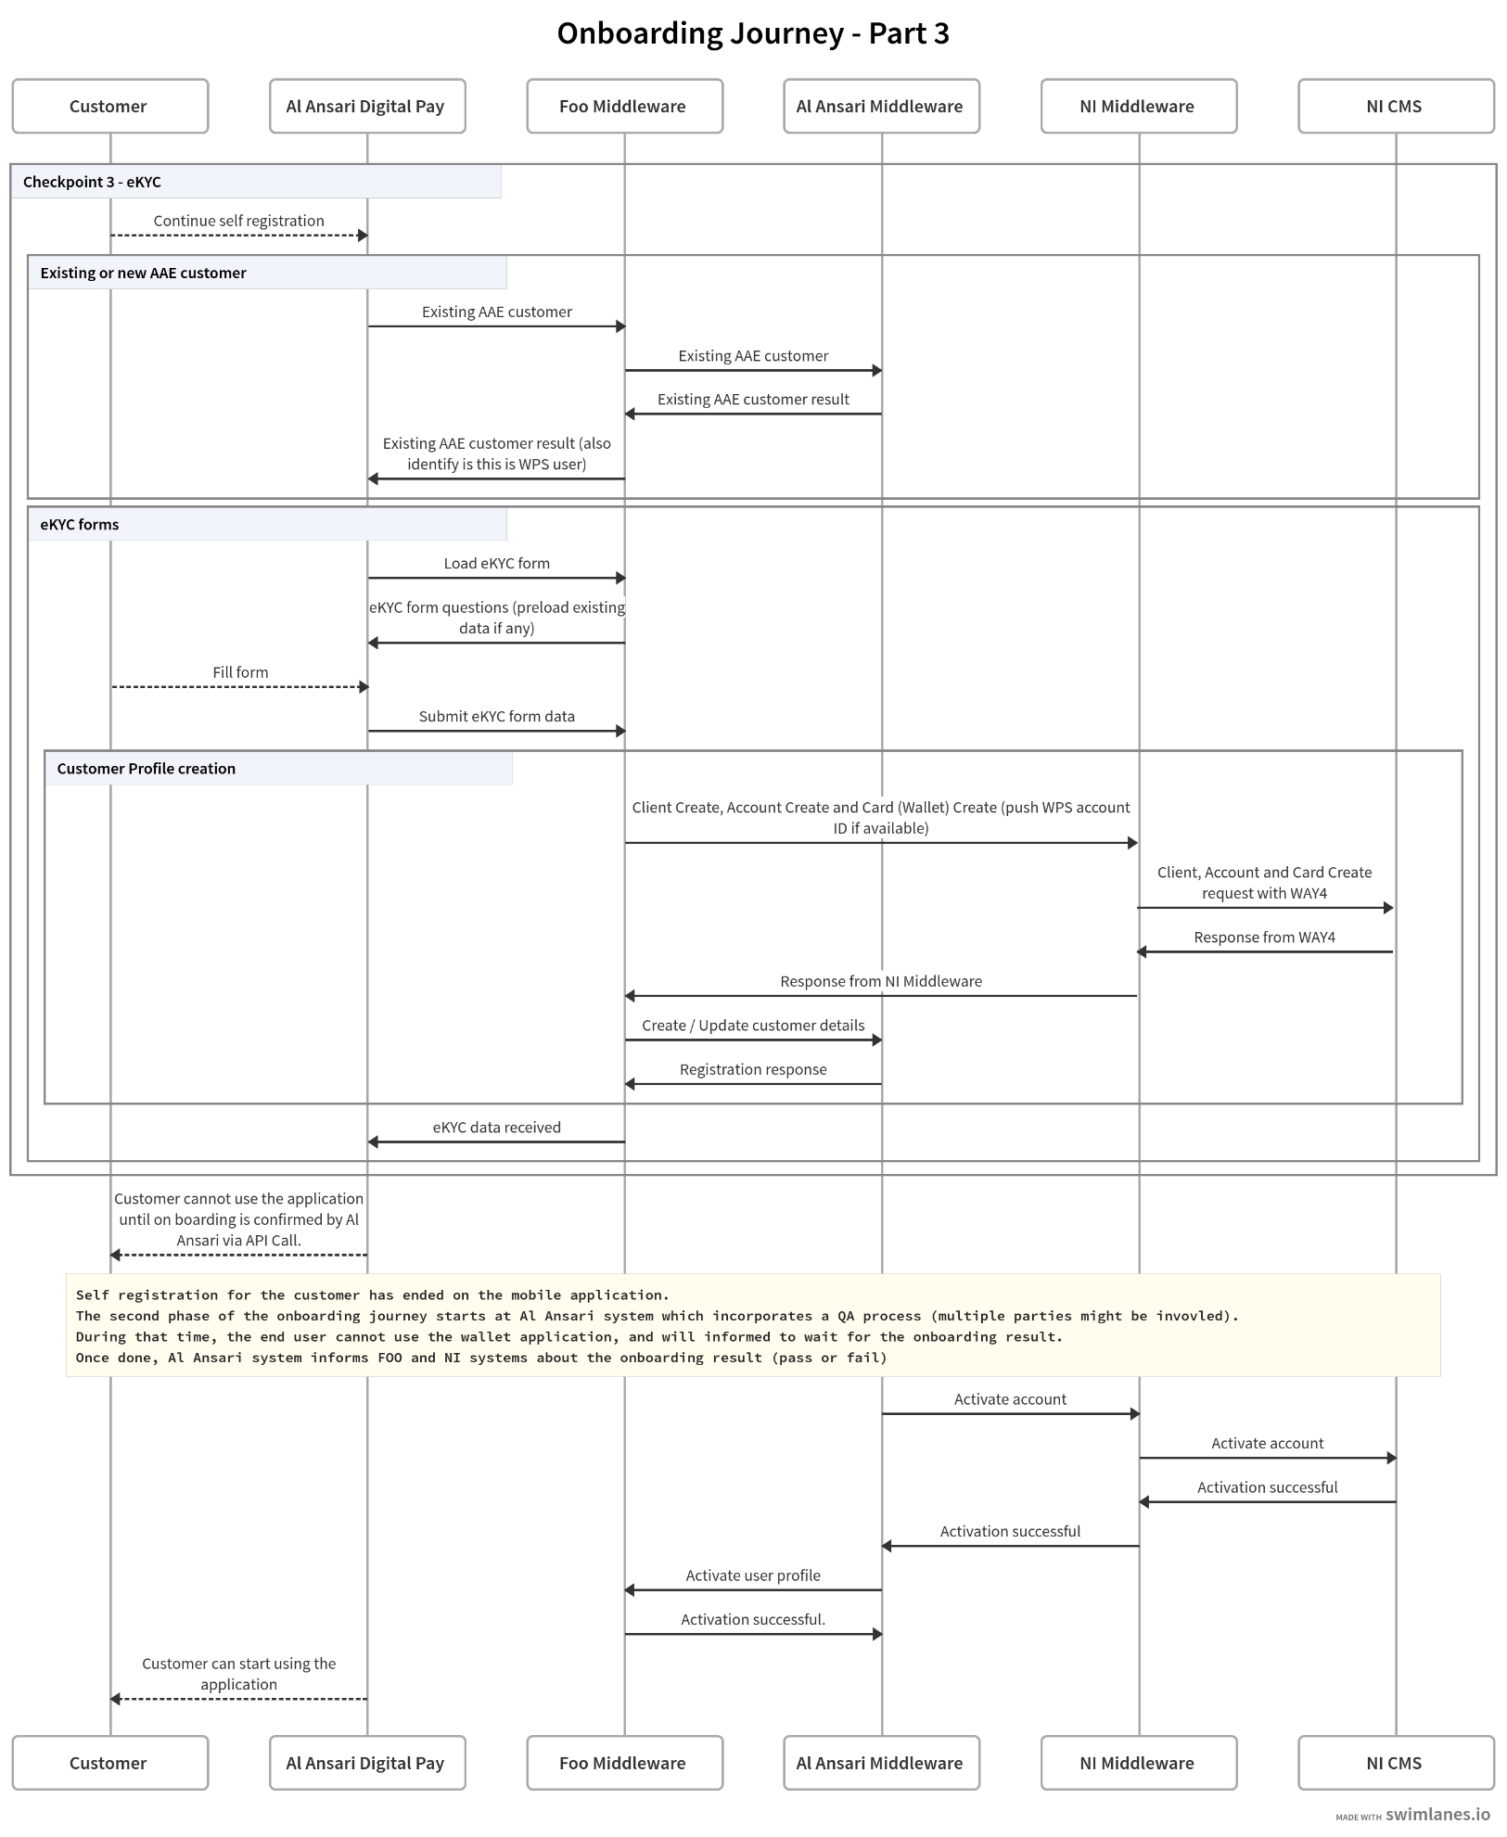

**Step 1**: The application communicates with FOO backend system to check with Al Ansari system if the current user is an existing or new AAE customer. Accordingly, Al Ansari Middleware will provide the available customer profile information for the case of an existing customer, along with WPS account ID if the user is enrolled in the salary program with Al Ansari.

**Step 2**: The application will request the eKYC form from FOO backend system, which will pre-load available answers for the case of an existing AAE customer, that would have been fetched from Al Ansari Middleware. The eKYC mandatory and optional fields will be provided be Al Ansari.

**Step 3**: The customer fills and updates the eKYC forms.

**Step 4**: The application submits the eKYC forms data to the FOO backend system.

**Step 5**: Upon submitting the form, FOO backend system proceeds with the customer profile creation, starting with NI system, followed by Al Ansari system.

**Step 5.1**: FOO Backend initiates multiple requests with NI Middleware to create the user wallet in NI CMS system using below standard APIs.

* + - * Create Client API - This API needs to be called to create a new client record in NI CMS. Some of the important fields expected in this API is as below. Upon successful execution, this API creates Customer record in the CMS system.
        + API endpoint: https://developer.network.ae/docs/read/card_services/version_2/Client_Create
        + Client number (CIF) generated by Al Ansari system.
        + Client demographic details i.e. Addresses – Present Address/Permanent Address, mobile number, email ID, Name, DOB, Citizenship, Postal code etc.
        + Client’s ID (~~Iqama ID~~) details
      * Create Account API - This API needs to be called to create a new account record in NI CMS. Some of the important fields expected in this API is as below. Upon successful execution, this API will return Account number which is generated in the NI CMS. This number will be used by Al Ansari for subsequent API call for creating the Wallet.
        + API endpoint: [[<https://developer.network.ae/docs/read/card_services/version_2/Account_Create>](https://developer.network.ae/docs/read/card_services/version_2/Account_Create)](https://developer.network.ae/docs/read/card_services/version_2/Account_Create)
        + Client number (CIF) of the customer for which an account is being created.
      * Create Wallet API – This API needs to be called to create a new wallet which will represent the client wallet in NI CMS. Some of the important fields expected in this API is as below.
      * Upon successful execution, customer wallet is created in NI CMS system with zero balance. The status of the Wallet will be in-active and needs to be activated for usage
        + API endpoint: [[<https://developer.network.ae/docs/read/card_services/version_1/Card_Create>](https://developer.network.ae/docs/read/card_services/version_1/Card_Create)](https://developer.network.ae/docs/read/card_services/version_1/Card_Create)
        + Client number (CIF) of the customer for which a Wallet is being created.
        + Account number for which for which a Wallet is being created

**Step 5.2:** FOO backend system captures the created client ID, account ID and Wallet ID in NI CMS, provided by NI Middleware, and stored them within FOO backend system linked to the currently logged in user.

**Step 5.3**: FOO backend system creates or updates (depending if this is the case of a new or existing customer) the customer profile at Al Ansari system via API calls.

**Step 6**: The application informs the customer that the onboarding is being reviewed and should be completed soon. At this stage the created wallet in NI CMS is inactive and the user profile in FOO is pending activation. Hence the customer cannot use the application, until the onboarding result is shared by Al Ansari.

**Step 7**: Once the activation process is completed on Al Ansari side, Al Ansari system notifies both NI Middleware and FOO backend system about the onboarding result (pass or fail). Therefore, Al Ansari Middleware calls an API in NI Middleware to activate the customer account / wallet, which will be reflected in NI CMS, and calls an API in FOO backend to activate the user profile.

**Step 8**: The customer is informed that the onboarding process is complete and the wallet can be used. Moreover, on every login / renew session on the application, the wallet status will be shared with FOO as part of card details inquiry API where the status of the card will be responded, using the following API: https://developer.network.ae/docs/read/card_services/version_2/Card_Details

## **Wallet Activation**

* The activation API will be exposed to Al Ansari, so that once customer screening and AML is completed. The activation request will be initiated from Al Ansari.
* Only after wallet activation, customer will be able to use payment services.
* Al Ansari to create a process to screen and initiate wallet activation request with NI CMS.
* Al Ansari to use below API for Wallet activation request - <https://developer.network.ae/docs/read/card_services/version_2/Card_Activation>

## **Maintaining or updating customer/wallet**

* Al Ansar can update the customer details in NI CMS portal via Citrix WAY4 Portal or vai API.
* Below APIs can be used to update the respective details in NI CMS –
  + Customer Demographics – The all demographics related to customer demographics - <https://developer.network.ae/docs/read/card_services/version_2/Client_Update>
  + Wallet management – The wallet details can be managed with API <https://developer.network.ae/docs/read/card_services/version_2/Card_Update>

## **Customer Classification**

* Al Ansari would like to have option to classify customer to restrict certain service for selected customers based on AML or sanctions that that are identified by Al Ansari.

Ex. Restricting Bill Payment and Remittance for customer.

* The customer classification can be updated via Al Ansari through Citrix WEB Access or via maintenance API’s that will be exposed to Al Ansari.
* Al Ansari to confirm the different status or classification and respective restriction to be placed for customers.

## **Acquirer Portal**

* Al Ansari teams will have access to an acquirer portal.
* This portal is dedicated to the merchant system.
* The merchant portal provides the below functionalities:
  + Merchant pre registration: Non registered merchants can fill a pre registration form that, once submitted, will be displayed in the acquirer portal for Al Ansari teams review. The form is view only and has no available actions. Al Ansari teams can contact the merchant accordingly outside the portal and initiate the portal onboarding on Al Ansari system, up until they get onboarded inside the acquirer portal (see next point).
  + Merchant onboarding: Al Ansari teams can manually onboard merchants from the acquirer portal. This registration will trigger a merchant wallet creation in NI CMS.
  + Merchant management: manage merchants and their configurations.
  + Transactions history: Al Ansari teams can view the transactions performed against the SVA wallet of the merchants, and download them as report files.
* The acquirer portal has maker / checker capability on the actions done, where, non view actions will require an approval to be performed.

## **Merchant Wallet Application**

* A Merchant Wallet application (different than the Customer Wallet) will be provided for merchant pre registration (form submission only) and payment acceptance.
* Al Ansari requested to have a Pre-registration option where the basic details will be provided by merchant. **AAE to provide the needed fields.**
* Al Ansari will complete the merchant onboarding via the acquirer portal. The invitation for merchants will be shared via email to registered email address. Merchants will use the invitation to register on the Merchant system and set credentials. Below is the proposed high level flow of merchant onboarding –
* In NI CMS the merchant SVA will be created for each merchant onboarded via merchant portal. The Client, Account and Wallet create API’s will be initiated from merchant portal once registration is completed by Al Ansari.
* Merchant Wallet application will have options to
  + Accept payment from customer by presenting QR (dynamic or Static QR)
  + View Balance for the SVA Wallet
  + View transactions history for the SVA Wallet
  + Request for settlement (future phases)

## **Merchant Portal**

* The merchants, once invited, will have access to a Merchant Portal.
* The merchant portal provides the below functionalities:
  + Merchant users management: The merchant admin can create multiple merchant users. Each can be assigned a role to perform specific actions. Each merchant user will have his own set of credentials.
  + Branches management: Every merchant can setup multiple branches, along with their details such as branch name, address, phone, opening hours and longitude / latitude (to be displayed on the map inside the consumer wallet application).
  + Terminals management: Manage and active the merchant terminal application (separate then the merchant wallet application) which will behave as a virtual POS.
  + Transactions history: Merchants can view the transactions performed against their SVA wallet, and download them as report files.
* The merchant portal has maker / checker capability on the actions done, where, non view actions will require an approval to be performed.

## **Merchant Terminal Application**

* The merchant terminal application is a standalone app that can be downloaded on a phone to behave as a virtual POS.
* The merchant terminal application requires a one time activation from the merchant, which is achieved by the merchant portal. No user credentials are required.
* Ther merchant terminal application can be used to accept payments via QR codes, mainly dynamic and static QRs.
* The merchant terminal application can display the transactions performed on that terminal only.

## **UX and UI For Customer and Merchant Application**

* The separate document will be provided to Al Ansari for sign-off on User Experience and User Interface for Customer application.

## **Customer, acquirer merchant portals**

* Foo will provide access to Customer portal for customer profile and views. Customer portal will have below options on high level (Foo to update the details ).
* Foo will provide access to acquirer and merchant portals for merchant onboarding, managing merchant profile.

## **Citrix Web Access**

* The WAY4 customer service portal access will be provided to Al Ansari via Citrix Web.
* The WAY4 portal will provide option of maker/checker access for transaction posting and customer demographics maintenance.
* Al Ansari will provide user access in below classifications –
  + View Only Access users
  + Maker
  + Checker

## **File/Reports interfaces**

### **Incoming offline Interface**

* NI supports financial and non-financial updates in bulk. This bulk request can be accepted by batch file interfaces in NI acceptable format. Al Ansari can place the files as per agreed naming convention, at designated SFTP location, and as per agreed frequency between NI and Al Ansari.
* Following incoming batch interfaces will be supported –

|  |  |  |
| --- | --- | --- |
| **Sl. No.** | **Interface name** | **Description** |
| 1 | Account boarding and demographic update | Application boarding and demographic upload |
| 2 | Financial posting service | Posting of financial transactions |

### **Outgoing offline Interface from NI to Al Ansari**

* As part of end-of-day process, NI generates data dumps which can be used by Al Ansari for MIS purpose. Following batch interfaces will be generated by NI CMS and transferred from NI to Al Ansari via SFTP as per agreed naming convention, at designated SFTP location, and as per agreed time between NI and Al Ansari.

|  |  |  |
| --- | --- | --- |
| **Sl. No.** | **Interface name** | **Description** |
| 1 | Client demographic dump | Client level demographic dump |
| 2 | Contract dump file | Contract dump |
| 3 | Card dump | Wallet level dump |
| 4 | Contract attribute dump | Contract attribute information |
| 5 | Account dump | Extraction of accounts details for all accounts that have not zero balance. |
| 6 | Address dump | Address dump of account, Wallet and client levels |
| 7 | Events dump | Dump for events triggered on particular day for contracts |
| 8 | Transaction dump | Daily transaction dump |
| 9 | Statement file | Statement file |

### **Outgoing offline reports from NI**

* As part of end-of-day processing or as a response to Adhoc batch file request, NI will generate the reports.
* Following functional reports will be generated by NI CMS and will be transferred from NI to Al Ansari via STPF as per agreed time between NI and Al Ansari.

|  |  |  |
| --- | --- | --- |
| **Sno.** | **Report name** | **Description** |
| 1 | New Accounts Report | New accounts boarded into the system on previous day |
| 2 | Customer & Address Maintenance Report | Generates in case of maintenance in customer and address details |
| 3 | Account Maintenance Report | Account level demographic maintenance report |
| 4 | Card Maintenance Report | Wallet level demographic maintenance details |
| 5 | Card Activation Report | Wallet activation report in particular day |
| 6 | Card Status Change Report | Generates once Wallet status is changed |
| 7 | Outstanding Authorization Report | Contains Authorizations not posted to cardholder |
| 8 | Trial balance by account | account level balance details |
| 9 | Generated Transaction Journal Report | System generated transactions details |
| 10 | Rejected Transaction Report | Rejected transactions |
| 11 | Activity Recap Report | Transactional activity report |
| 12 | Application boarding / demographic response report | Response report for application boarding file/demographic update file |
| 13 | Financial posting response report | Response report for financial posting file |
| 14 | User Maintenance Report | Report shows addition/modification or deletion of system user. |
| 15 | System User Report | This report populates all the users details of the Financial Institution |

## 

## **APIs in scope**

* Following Inbound APIs will be exposed to Al Ansari and FOO.

|  |  |  |
| --- | --- | --- |
| **Report name** | **Description** |  |
| Client Create | To create a new Customer record | <https://developer.network.ae/docs/read/card_services/version_2/Client_Create> |
| Client Update | To update an existing Customer record | <https://developer.network.ae/docs/read/card_services/version_2/Client_Update> |
| Account Create | To create a new Account record | <https://developer.network.ae/docs/read/card_services/version_2/Account_Create> |
| Account Update | To update an existing Account record | <https://developer.network.ae/docs/read/card_services/version_2/Account_Update> |
| Card Create | To create a new Wallet record | <https://developer.network.ae/docs/read/card_services/version_2/Card_Create> |
| Card Update | To update existing Wallet record | <https://developer.network.ae/docs/read/card_services/version_2/Card_Update> |
| List of Cards | To retrieve a list of Wallets linked to a customer or an account | <https://developer.network.ae/docs/read/card_services/version_2/List_Of_Cards> |
| Customer Details | To retrieve detail of existing customer using customer number | <https://developer.network.ae/docs/read/card_services/version_2/Customer_Details> |
| Card Details | Wallet Details service is used for querying wallet details. | <https://developer.network.ae/docs/read/card_services/version_2/Card_Details> |
| Card Balance Enquiry | To get the balance details of a given wallet number | <https://developer.network.ae/docs/read/card_services/version_2/Card_Balance_Enquiry> |
| Transaction Detail | To retrieve authorized or posted transactions based on the date-range or number of transactions | <https://developer.network.ae/docs/read/card_services/version_2/Transaction_Details> |
| Transaction | Transaction posting API to post Credit or Debit Transactions. | <https://developer.network.ae/docs/read/card_services/version_2/Card_Transaction> |
| Card Activation | To activate the wallet this API can be used | <https://developer.network.ae/docs/read/card_services/version_2/Card_Activation> |

* All API Specifications can be accessed from below developer portal -

<https://developer.network.ae/docs/read/card_services/version_2>

## **Infra set up**

* NI will provide with connectivity with the following components to Al Ansari via VPN. Applications will be accessible via DR as well.

1. Way4web portal
2. API gateway
3. SFTP Server (for file/reports exchange)
4. Application management portal (To be updated by Foo)

* NI will provide with 1 dev/SIT region, 1 UAT region to Loop during project execution.

# Key Assumptions/Solution Considerations

* Client number will be generated by Al Ansari, while Account number and Wallet ID will be generated by NI.
* For API integration between Al Ansari and NI, Al Ansari will adopt to NI API specs.
* Customer (Client/Account/Wallet) onboarding will be done via NI standard APIs.
* Al Ansari will adapt to NI’s standard API Specs for inbound APIs to NI. Al Ansari will integrate with NI via NI API gateway to consume inbound APIs.
* Al Ansari will adapt to NI’s standard batch interface and report specs for incoming and outgoing batch interface integrations. NI will exchange batch interfaces and reports to/from Al Ansari via SFTP.
* SMS delivery/Push notification to end customer will be managed by Al Ansari.
* UAT will be done by Al Ansari. NI and Foo will provide UAT Support

# Out of Scope

# Queries/Outstanding points

* UAT will be done by Al Ansari. NI will provide UAT Support

# Appendix

* Incoming and Outgoing interfaces
* Reports